RA’26 Project

8-Puzzle Solver project using A*, UCS, and Greedy — heuristic design, state representation, and benchmarking methodology.

State representation
The puzzle state is a 3×3 grid with tiles 1–8 and one blank (0). The representation is a Python list of 9 integers.
python
# Goal state
GOAL = [1, 2, 3, 4, 5, 6, 7, 8, 0]
# Example scrambled start
START = [1, 2, 3, 4, 0, 6, 7, 5, 8]
Each node in the search tree stores the state, a reference to its parent node, the action taken (UP/DOWN/LEFT/RIGHT), and the path cost g. From any state, you generate successors by finding the blank's index, checking which moves are valid (no going off edges), and swapping the blank with the target tile.

The three algorithms
What differs is the priority function f(n):
# A*: f(n) = g(n) + h(n) — optimal if h is admissible
# UCS: f(n) = g(n) — ignores heuristic entirely
# Greedy: f(n) = h(n) — ignores path cost entirely
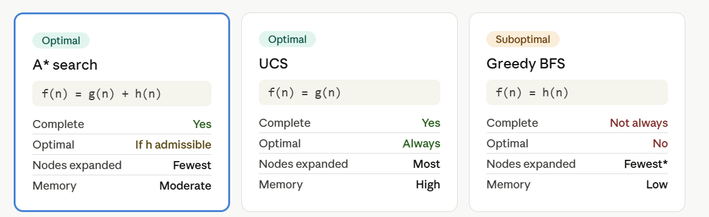

Heuristic design
Three heuristics are worth implementing in this project, in increasing strength:
h1 — Misplaced tiles. Count tiles not in their goal position (excluding the blank). Simple O(n), always admissible because each misplaced tile needs at least one move.
python
def misplaced(state):
return sum(s != g and s != 0 for s, g in zip(state, GOAL))
h2 — Manhattan distance. Sum the horizontal + vertical distances of each tile from its goal position. Strictly dominates h1 (always ≥), so A* with h2 expands fewer nodes than with h1.
python
def manhattan(state):
total = 0
for i, tile in enumerate(state):
if tile == 0: continue
goal_i = GOAL.index(tile)
total += abs(i//3 - goal_i//3) + abs(i%3 - goal_i%3)
return total
h3 — Linear conflict (challenge extension). Manhattan distance + 2 for every pair of tiles in the same row/column that must pass each other to reach their goals. Admissible, dominates h2, cuts nodes further on harder puzzles.
The key teaching point is the dominance chain: h3 ≥ h2 ≥ h1 ≥ 0. A more informed heuristic never expands more nodes than a weaker one under A*.
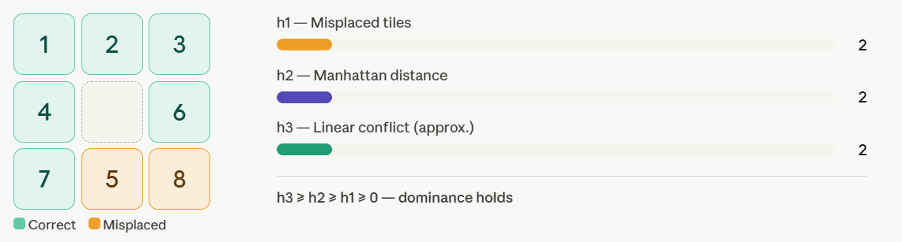Move the tiles by clicking any tile adjacent to the blank — watch the three heuristic values update live and confirm that h3 ≥ h2 ≥ h1 holds throughout.

Implementation
You should implement the template code using any type of heuristic, (Bonus - if all heuristics are implemented)
also the fullpath is required while the actual path (path) is a bonus you can return an empty list if you do not want the bonus.
Other algorithms as BFS, DFS are Bonus.
You can add as many functions as you want but the main will not be changed, also you can update the 3 functions (Astar, UCS, Greedy) but they should have the same return.
Also the code should be in one (.py) file.
kindly be noted Do Not change the main code , and make sure that the 3 functions (Astar, UCS, Greedy) should return 3 variables as provided in the template.

Here is the link to the form registration: link

